# 

WIREFRAME

## Insurance Premium Prediction

## Done By: Md Rian Ur Rahaman

Contents

Abstract

1. Web App Interface

1.1 Landing Web Page

2. User Input

3. Result Page

## Abstract

This data science project focuses on developing a comprehensive solution to predict and mitigate customer churn in a subscription-based business model. The project follows a systematic end-to-end approach, encompassing data collection, preprocessing, exploratory data analysis (EDA), feature engineering, model selection, training, and deployment. The primary objective is to empower businesses with actionable insights to retain valuable customers and optimize revenue streams.

The project begins with data collection from diverse sources, including customer interactions, transaction history, and demographic information. Data preprocessing involves cleaning, handling missing values, and transforming raw data into a format suitable for analysis. The EDA phase employs statistical and visual techniques to uncover patterns, correlations, and potential factors influencing customer churn.

The project emphasizes the importance of interpretability, providing stakeholders with clear insights into the factors contributing to customer churn. Model explanations and visualizations aid in understanding the decision-making process and guide strategic decision-making.

The selected model is then deployed into a production environment, allowing real-time predictions on new data. Integration with existing systems and continuous monitoring ensure the model's effectiveness over time.

The project concludes with a comprehensive evaluation of the entire process, including model performance metrics, business impact, and insights gained.

By implementing this end-to-end data science project, businesses can proactively address customer churn, reduce revenue loss, and enhance overall customer satisfaction.

1. Web App Interface :

This is a basic Home Page , just welcoming the users. It is made by HTML,CSS.

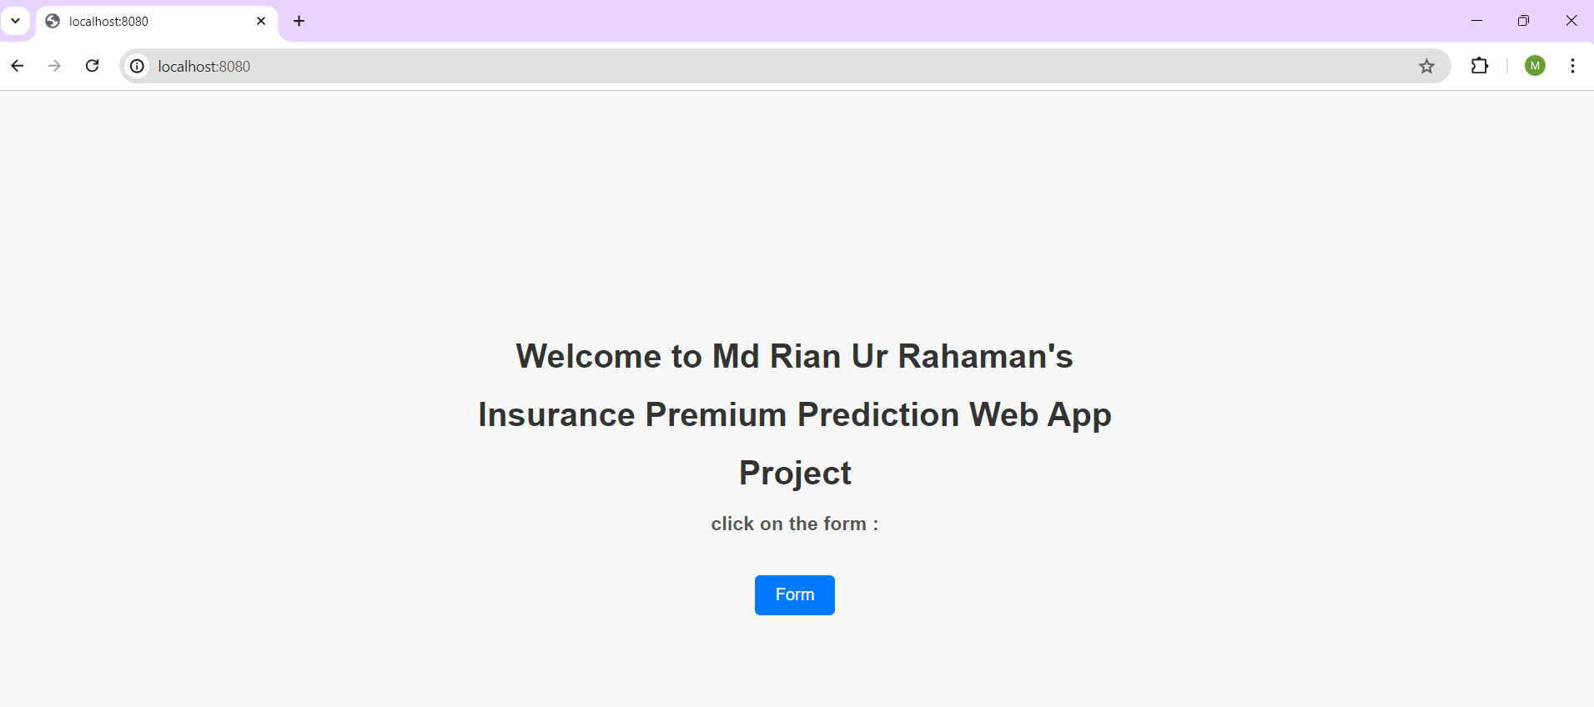

* 1. Landing Web Page

By clicking the form button , we can go to main web app page to calculate the actual insurance premium

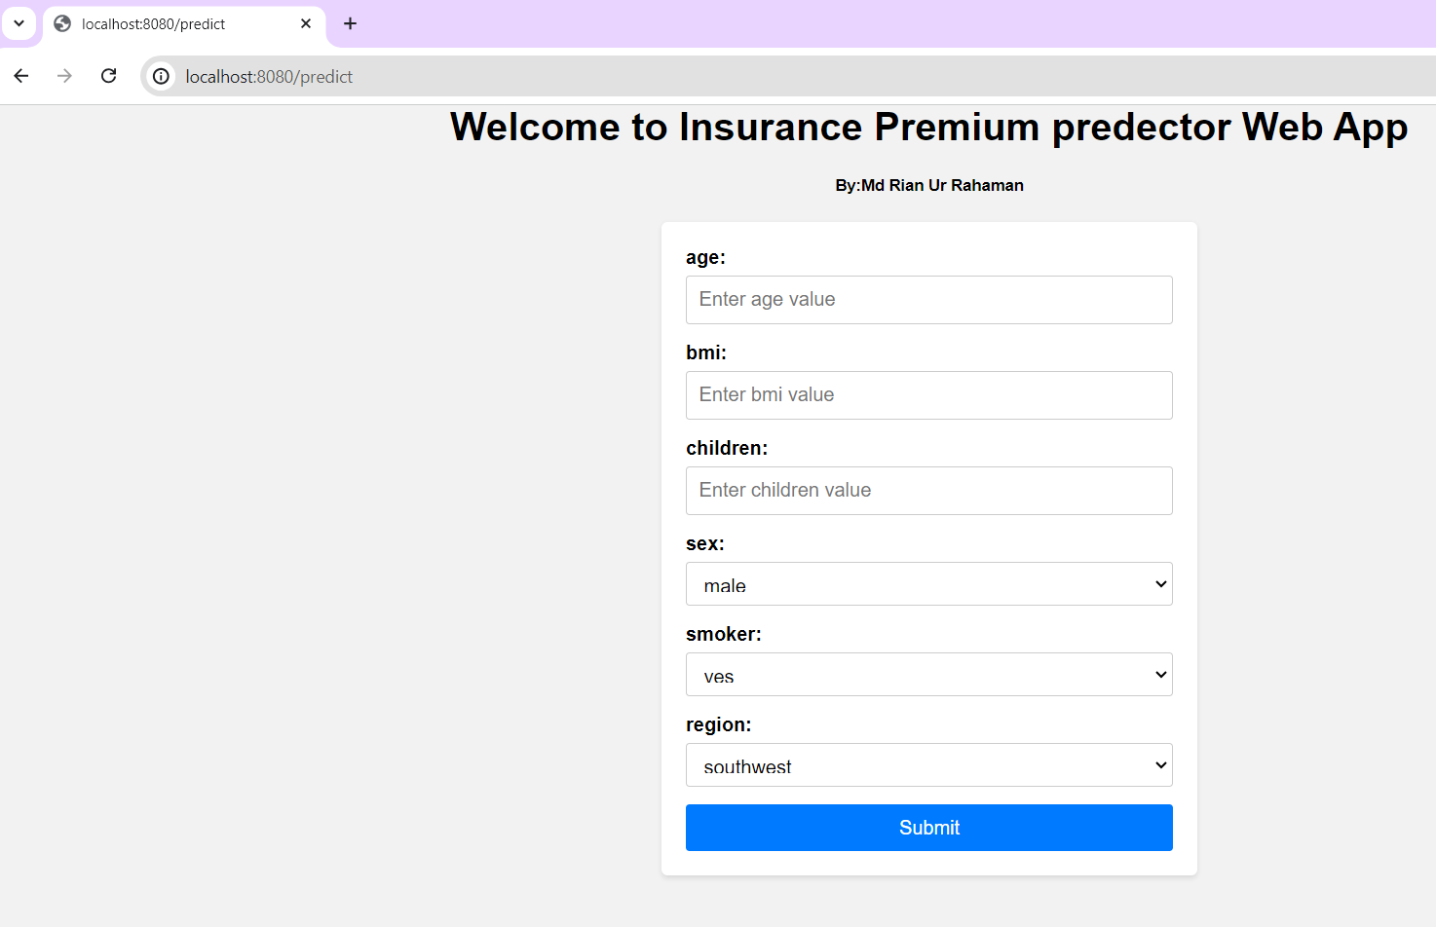

2 User Input :

Here we can give value of age , bmi , children no , smoker , region .

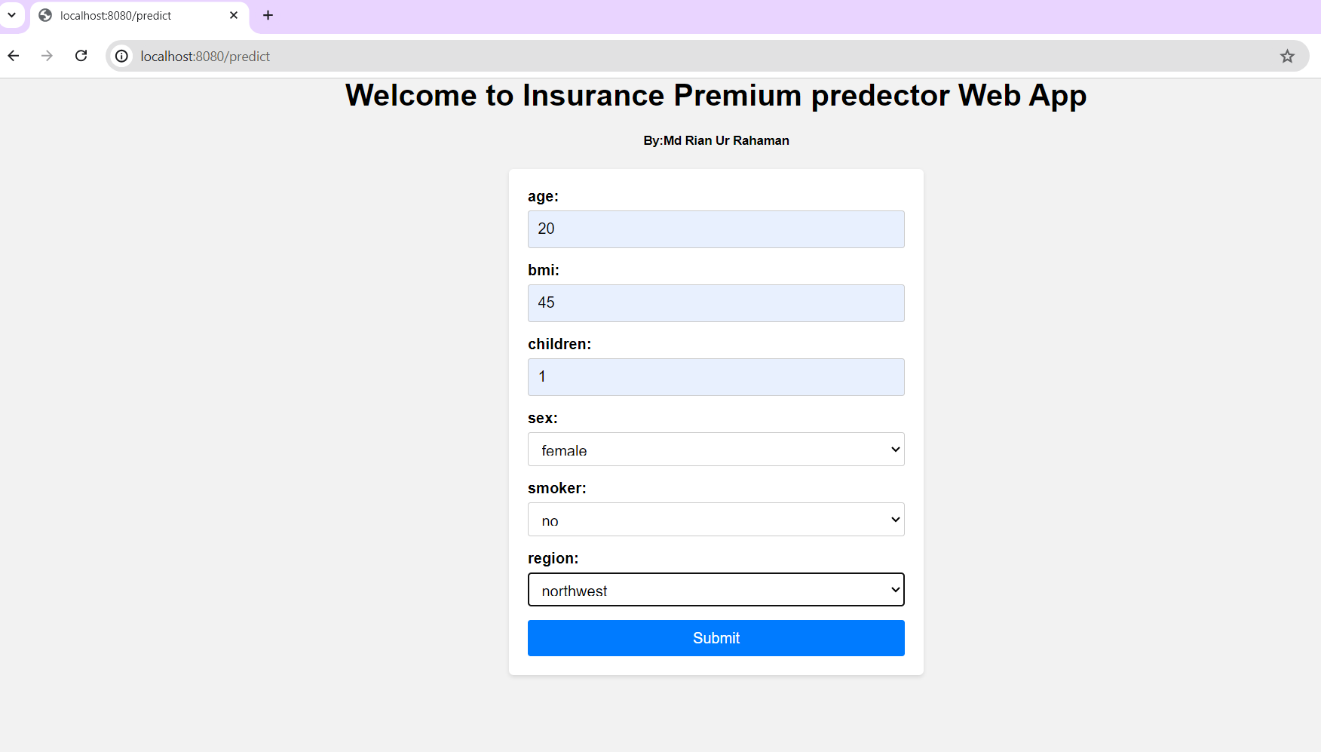

1. Result Page :

